
Lesson 9: On the Scoreboard
GDevelop
VIDEO GAME CREATION
This week: track a real score, and show it - along with your lives - on screen, all the time, not just at the end.
Open your own [YourName]Game project from Lesson 8 - don't start a new one.
Tip: no new assets this week - this is a logic and UI lesson.

Setup
- Open your [YourName]Game project from Lesson 8.
- Add two Text objects, name them ScoreText and LivesText, and place them in a corner of the scene. Leave both visible (unlike WinText/LoseText, these stay on screen the whole game).
- Add a new scene variable Score, default value 0.

Level 1 - Minimal (MVP)
Destroying an enemy adds 10 points to your score. Score and lives are both visible on screen, all the time, not just at the start or end of the game.
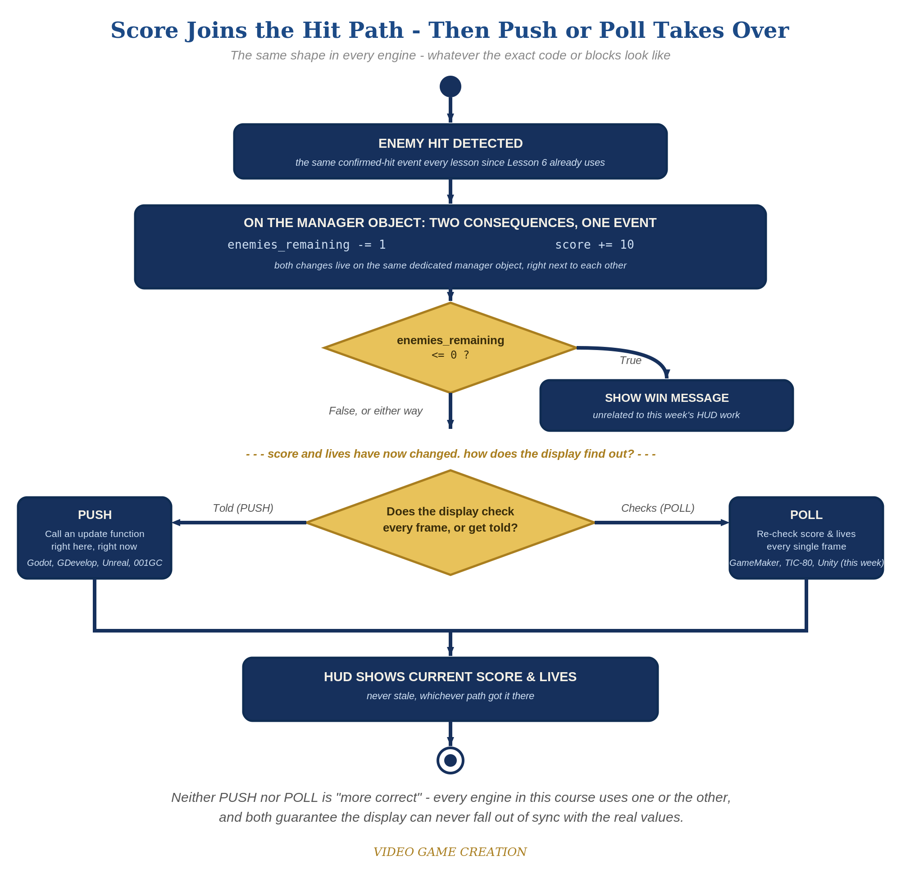
Score joins the hit path, then Push or Poll takes over - the same shape in every engine, whatever the exact code or blocks look like.
- In the Combat event group's collision event, add a new action: Score = Score + 10, alongside the existing EnemiesRemaining action.
- Add a new "always" event (no condition) with two actions: change the text of ScoreText and LivesText to show the current values (code below).
- Click the green Preview button, shoot a few enemies, and let one escape - both text objects should update immediately every time.
Highlighted lines are new this week; everything else is code you already have.
(Combat event group)
Condition: Bullet is in collision with Enemy
Action: Play a sound (sfx_hit.wav)
Action: EnemiesRemaining = EnemiesRemaining - 1
Action: Score = Score + 10
Action: Delete Bullet
Action: Delete Enemy
(new event, always - no condition)
Action: Change text of ScoreText: "Score: " + ToString(Score)
Action: Change text of LivesText: "Lives: " + ToString(Lives)

Level 2 - Complete (Alpha/Beta)
The score and lives readouts never show a stale or wrong number - they always match reality, immediately.
- Shoot 3 enemies and confirm ScoreText reads exactly "Score: 30".
- Let an enemy escape and confirm ScoreText does NOT change - only LivesText should move.
- Because the HUD-update event has no condition, it runs every single frame - the display can never be stale.

Level 3 - Refined (Ready to Publish) - pick any that interest you
- Visual: style ScoreText and LivesText's font/color in the object editor for a more game-like HUD look.
- Visual: change points-per-kill to a randomized value using GDevelop's Random() expression, e.g. Score = Score + (5 + Random(10)).
- Structure: group the new HUD-update event into its own labeled group (e.g. "HUD"), separate from Combat, Spawn, and Movement - continuing the organizational habit from Lesson 7.

If Something's Wrong
- Score text never updates: confirm the always-event's action actually references the Score variable (ToString(Score)), not a typo'd or different variable name.
- Score changes when an enemy escapes: confirm the Score = Score + 10 action is only inside the Combat group, not accidentally added to the escape-cleanup event too.
- ScoreText and LivesText overlap on screen: reposition one of them in the scene editor.

Want More?
Student Resource List > GDevelop section, or gdevelop.io/tutorials

